DESIGN, DEVELOPMENT, AND ON-ORBIT PERFORMANCE OF THE ADVANCED CONTROLS TECHNOLOGY EXPERIMENT

R. A. Manningand S. C. Casteel
TRW Space and Electronics Group

Abstract
The Advanced Controls Technology Experiment (ACTEX) was placed on-orbit in the middle of 1996 and has been returning system identification and active controls data. This paper discusses the design and development of the ACTEX system and summarizes the results of the on-orbit data received to date.
The system itself consists of an active tripod structure and a set of programmable electronics. The active tripod, which is traceable to many precision optical sensor support structures, utilizes piezoceramic actuators and sensors embedded in a composite host layup. The flight electronics contain a number of pre-programmed experiments, the capability to change experiment/controller parameters by command from the ground, the command/control electronics, and signal processing electronics.
The original objective of the ACTEX program was to demonstrate in space the robustness, flexibility, and reliability of “intelligent structures”. The system is currently operational, in space, and has been returning high quality system identification and vibration suppression experiment data. System identification experiments, active control experiments, and adaptive control experiments are planned for the future.

Background
Advanced structural control technology has proceeded at a rapid pace in a laboratory setting. Advances in performance and robustness algorithms, actuator and sensor hardware technology, and flexible electronics have all contributed to this rapid rate of progress. A large number of ground testbeds (Ref. 1) have test-verified these advances and contributed to a significant “technology push” into future space missions.
Simultaneously a number of upcoming BMDO and DoD space systems have publicized extremely stringent vibration and shape requirements to achieve their primary mission. Over the years these requirements have become more stringent as higher levels of performance are required from lighter and cheaper space systems. Active vibration and shape control has thus become an enabling technology for many of these missions. Hence creating a significant “technology pull” from future space missions.
The Advanced Controls Technology Experiment (ACTEX) was intended to be the bridge between laboratory-proven controls technologies and performance hungry space missions. Demonstration of advanced identification and controls algorithms, actuator and sensor hardware, and flexible electronics in the space environment would be a significant step in inserting these technologies into operational or future spacecraft.
The ACTEX (Refs 2 and 3) program utilized the most promising multidisciplinary technologies for attaining the success of future space missions. Active structures, with embedded (Ref. 4) piezoceramic actuators and sensors, have been validated on the ground and were chosen for in space demonstration. Local rate and position control loops were used on ACTEX as a first logical step in demonstrating intelligent structure on orbit. Advanced control algorithms, such as impedance matching compensators (Ref. 5) and robust controllers (Ref. 6), have yielded simultaneous gains in performance and stability, but were deemed not fully mature for space insertion. Flexible electronics (Ref. 7), for ease of uplink programmability, were chosen for ACTEX.
The primary objectives of the effort were to demonstrate system identification algorithms, demonstrate the performance level of advanced control hardware and software, demonstrate adaptive control technologies, and to gather life data on the control components.

Flight Experiment Description
The flight experiment hardware consists of an active tripod structure and experiment command, control, and signal conditioning electronics. A photograph of the active tripod (minus cabling and thermal blankets) is shown in Figure 1.
The active flight structure consists of a tripod with three active legs. Piezoceramic actuators and sensors embedded in the graphite composite host material provide the actuation and sensing mechanism for the experiment. Wiring integral to the composite host provides leads for each actuator and sensor. By appropriately connecting each leg together, two axes of lateral bending control and torsional control can be implemented.
The active legs of the tripod utilize piezoceramic wafers embedded in a graphite epoxy layup for the sensors and actuators. Square cross sections for the legs of the tripod were employed to ease the processing of the active members and to employ the processes developed on a related contract (see Ref. 4). The encapsulation process described in Ref. 4 was used for easier handling of the piezoceramic material and less susceptibility to cracking during the graphite epoxy cure process. Each side of the square tripod legs has a double-layered PZT actuator string and two PZT sensors. One of the sensors is colocated with the actuator string while the other is nearly colocated. Two sensors per leg give added redundancy to the experiment and allow averaging of the sensor measurements. By averaging these two sensor measurements, the transfer functions that the active members “see” can be tailored to be advantageous for the local control loop design task.
Integration and experiment objectives drove the configuration of the experiment on the host spacecraft. The tripod took on a tall narrow look due to hard constraints imposed upon the flight unit by the host spacecraft. An external mounted active structure allows lifetime and reliability data on the active control components to be obtained in the harsh space environment. Experiment reliability was maximized, however, by mounting the electronics internal to the spacecraft where they would be shielded from the space environment and excessive amounts of radiation. Cables from the piezoceramic actuators and sensors and tripod-mounted accelerometers run though a feedthrough connector in the deck of the host spacecraft to provide connectivity between the host spacecraft, the electronics, and the active tripod.
The flight unit electronics consists of electronic slices which perform distinct on-orbit functions.. Overall executive control of the experiment, interfacing with the host, running pre-programmed or customized experiments, and data storing and downlinking are performed in the command/control slices. Conditioning of the accelerometer and thermistor data is contained in separate slices within the electronics unit. Control loop logic and circuitry as well as piezoceramic actuator drive and sensor conditioning electronics are contained in the active strut electronics slices. A stand alone, solid state data recorder stores data taken during a single sixty second experiment until the host is available to downlink the data to the ground.
The thermal control system for the active tripod consists of heaters, thermostats, and multi-layer insulation (MLI) blankets. Two heaters, one located on the top plate of the tripod and one located on the bottom bracket (spacecraft interface) of the tripod, provide heat input. Primary and redundant thermostats colocated with the heaters provide thermal control temperature information. Additionally, nine thermistors mounted in various locations on the experiment provide temperature data available for data collection and storage during a sixty second experiment. Thermal blankets were wrapped around the tripod top plate and the bottom bracket to help maintain temperatures within the calibration range of the flight accelerometers.

Experiment Descriptions
Eighty-two system identification, active vibration control, and adaptive control experiments were pre-programmed into the onboard PROM. These experiments can be run as is or be customized from the ground via the spacecraft uplink. Each experiment consists of a sixty second data collection sequence which was divided into ten second intervals. Dividing each experiment into intervals in this manner allows multiple types of experiments to be run during any single sixty second experiment. For example, system identification experiments, free vibration response, forced vibration response, open or closed loop experiments, and selective closed loop running can be performed in any sixty second experiment. Set up as such, maximum flight data can be obtained from minimum host spacecraft attention.
A typical channel of data coming down from the ACTEX I flight unit is shown in Figure 2. The data shown is for a system identification experiment where each control actuator is excited in turn with white noise for ten seconds followed by a ten second period of no excitation.

Available Telemetry Data
The active tripod is instrumented with 13 low noise accelerometers to monitor the input base motion and top plate motions. All three translational and rotational degrees of freedom of both the top plate and the bottom bracket can be recovered from the accelerometer measurements. Piezoceramic actuator drive and averaged sensor signals are also available for downlinking. A number of thermistors were located on the three legs of the structure as well on the bottom bracket and top plate in order to determine the temperature of the varying components.

On-Orbit Performance
Following a three year storage period of the host spacecraft, the ACTEX flight experiment was launched in mid 1996. To date, eight experiments have been run on the unit. The results of each of these experiment runs are shown in Table 1.
The first two runs, intended to initially check the unit out in space, were marred by a noisy and unreliable host spacecraft downlink. The downlink problems with the host were fixed (with the aid of the ACTEX data and command sequences) and subsequent experiments were run.
The next three runs, intended to identify and baseline the performance of the flight unit, ran successfully. Transfer functions between each actuator and piezoceramic sensor pair as well as between each actuator and accelerometer were obtained. The actuator/piezoceramic sensor transfer functions provided the data needed to compute sensor averages for subsequent runs.
It took two runs to compute the averaged transfer functions. The initial experiment ran but provided no useful data to some event setting off the over-vibration circuit (and sending the experiment into a safe mode). Figures 3 and 4 show the averaged transfer function for a single channel of data taken on the ground (at integration time) and on-orbit. Without the “dirty” noise of air conditioning systems and seismic motions observed on the ground, the on-orbit data looks very similar to that taken on the ground. In most instances, the on-orbit behavior of the ACTEX I structure is similar to the ground-based test data. Differences between the data can be attributed to the final partial installation of thermal blankets, aging of the structure for the three year storage, the absence of gravity on-orbit, and other effects.
Figures 5 and 6 show a comparison of the open and closed loop performance of the ACTEX flight unit on-orbit. The active control system provides 24 dB of vibration attenuation in the 24 Hz mode and 16 dB in the 30 Hz mode. These levels of vibration reduction were consistent with those seen on the ground at integration time.

Concluding Remarks
The ACTEX I experiment is on-orbit and returning meaningful data to the ground. A complete set of system identification experiments have been run and the first closed loop experiment was run. The data received thus far indicates that the experiment is functional and producing data similar to that seen on the ground.
Vibration reductions of up to 24 dB were observed during the first closed loop experiment. Additional vibration attenuation and damping of more modes will be attempted in subsequent on-orbit experiments by tuning the control parameters.
Following a number of closed loop experiments, adaptive control experiments, and lifetime/reliability data-gathering experiments, the ACTEX I flight unit will be available for Guest Investigators on a limited basis.

Acknowledgments
Lt. Col. Mike Obal, formerly of BMDO was instrumental in pushing the ACTEX I project. Dr. Alok Das and Ken Qassim of the Air Force Phillips Laboratory were motivational technical monitors during the effort. Dr. S. Roy Schubert of TRW was the project manager during the original ACTEX I design/fab/test endeavor. Rick Wyse served as chief architect/designer for the ACTEX I electronics.

References
- Sparks, D.W. and Juang, J-N., “Survey of Experiments and Experimental Facilities for Control of Flexible Structures”, J. of Guidance, Control, and Dynamics, Vol. 16, No. 4, July-August, 1992, pp. 801-816.
- Manning, R.A., Wyse, R.E., and Schubert, S.R., “Development of An Active Structure Flight Experiment”, presented at the AIAA/AHS/ASEE Aerospace Design Conference, Irvine, CA, February 16-19, 1993.
- Manning, R.A., Wyse, R.E., and Schubert, S.R., “An Advanced Controls Technology Flight Experiment”, presented at Damping ‘93, San Francisco, CA, February 24-26, 1993.
- Betros, R.S. and Dvorsky, G.R., “Encapsulation Technique to Enhance Actuator Performance in Composite Beams”, presented at the Fourth NASA/DoD Controls-Structures Interactions Technology Conference, Orlando, FL, November 5-7, 1990.
- Chen, G-S., Lurie, B.J. and Wada, B.K., “Experimental Studies of Adaptive Structures for Precision Performance”, Proceedings of the AIAA/ASME/ASCE/AHS/ASC 30th Structures, Structural Dynamics, and Materials Conference, Mobile, Alabama, April 3-5, 1989, pp. 1464-1472.
- Doyle, J.C. “Analysis of Feedback Systems with Structured Uncertainties”, IEEE Proceedings, Vol. 129, Part D, No. 6, Nov. 1982, pp. 242-250.
- Bronowicki, A.J., Mendenhall, T.L., Wyse, R.E., and Innis, J.W., “ACESA Structural Control System Design”, presented at the First Joint U.S./Japan Conference on Adaptive Structures, Maui, HI, November 13-15, 1990.

Table 1. On-Orbit Experiment Status Summary
Experiment Identifier | Objective | Experiment  Type | Dynamic Behavior | Thermal  Behavior | Experiment Status
E1R1 | Flight unit debugging | Preprogrammed | Unknown | Unknown | Many D/L errors detected. Host to change D/L parameters
E1R2 | Flight unit debugging | Preprogrammed | Unknown | TP²: -68C  BB: +10C | Some D/L errors detected. Unit functions and responds to commands
E1R3 | System ID  CL Sensor TFs | Preprogrammed | Similar to ground data | TP: -74C  BB: -20C | Successful. Computed CL TFs for sensor averaging. Computed accel TFs
E1R4 | System ID  CL Sensor TFs | Hybrid¹ | Similar to ground data | TP: -72C  BB: -7C | Successful. Computed CL TFs for sensor averaging. Computed accel TFs
E1R5 | System ID  CL Sensor TFs | Hybrid | Similar to ground data | TP: -72C  BB: -10C | Successful. Computed NCL TFs for sensor averaging
E1R6 | System ID  NCL Sensor TFs | Hybrid | Unknown | TP: -72C  BB: -7C | Tripped over-vibration circuit. No useful data obtained
E1R7 | System ID  Averaged TFs | Hybrid | Similar to ground data | TP: -37C  BB: +20C | Successful. Demonstrated sensor averaging similar to on the ground
E30R1 | Vibration Control | Hybrid | Similar to ground data | TP: -60C  BB: +11C | Successful. Demonstrated 24-16 dB response reduction
¹ Preprogrammed experiment with custom parameters
² TP - Top Plate, BB - Bottom Bracket

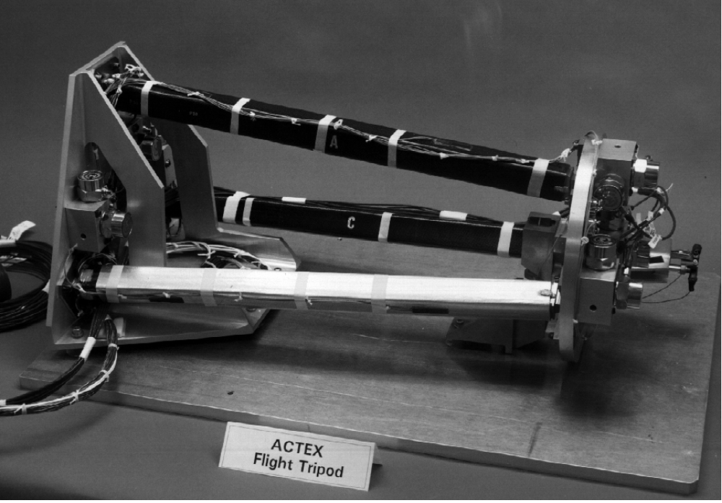
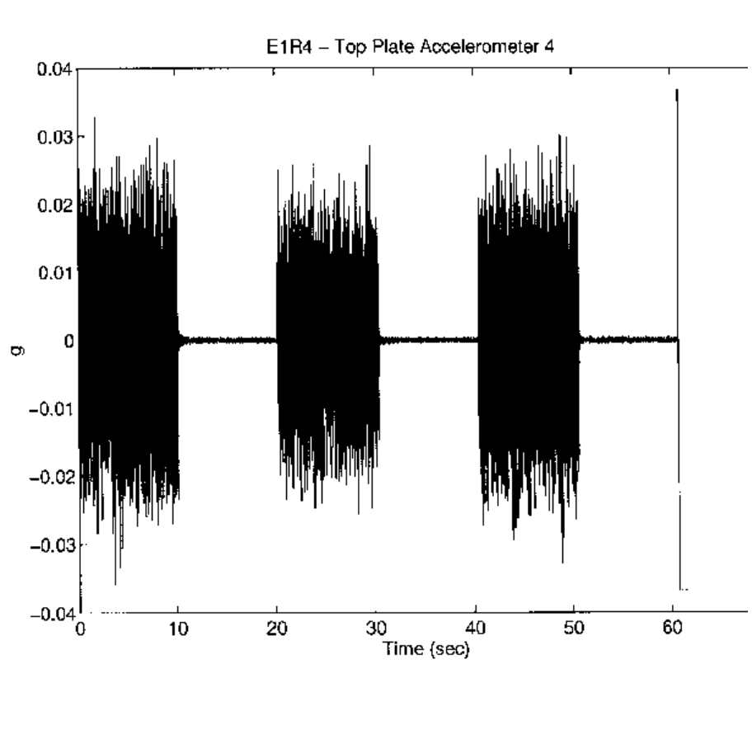
Figure 1. ACTEX I Flight Structure
Figure 2. Typical Downlinked Data, Top Plate Accelerometer, Exp. 1, Run 4
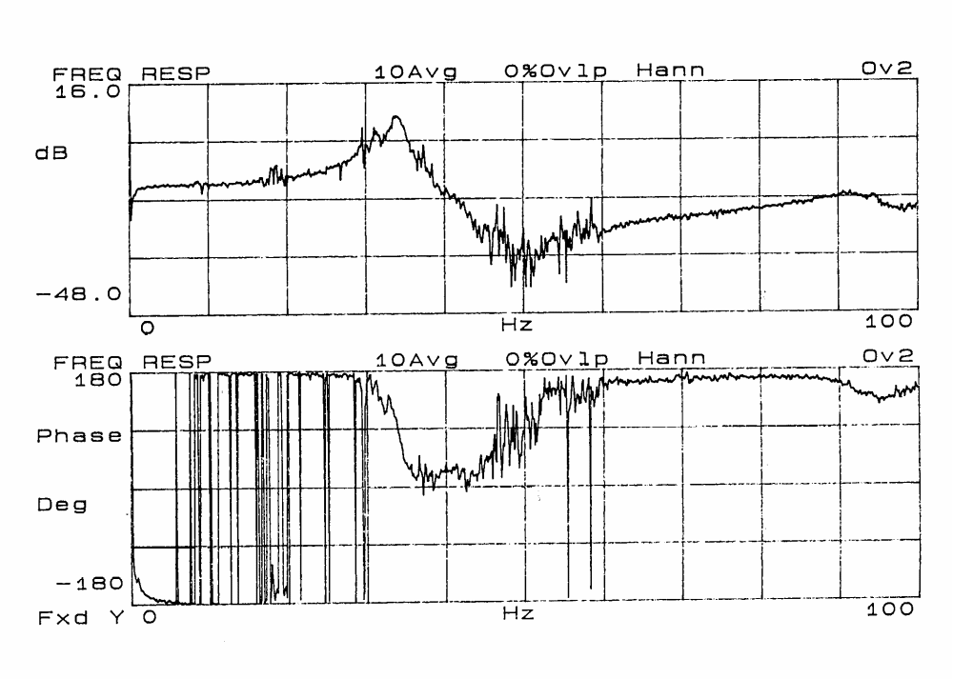
Figure 3. Active Member Transfer Function, Averaged Sensor, Exp 1. Run 7
Ground Data
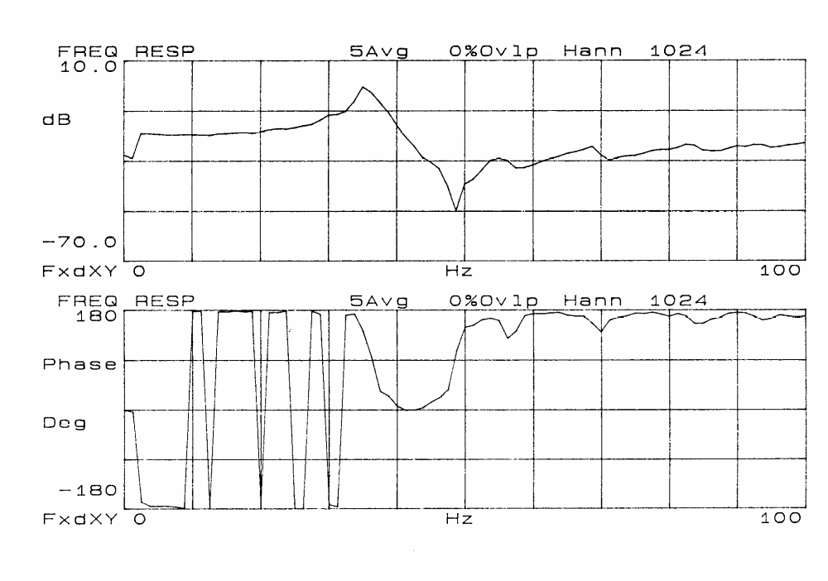
Figure 4. Active Member Transfer Function, Averaged Sensor, Exp 1. Run 7
On-Orbit Data Data
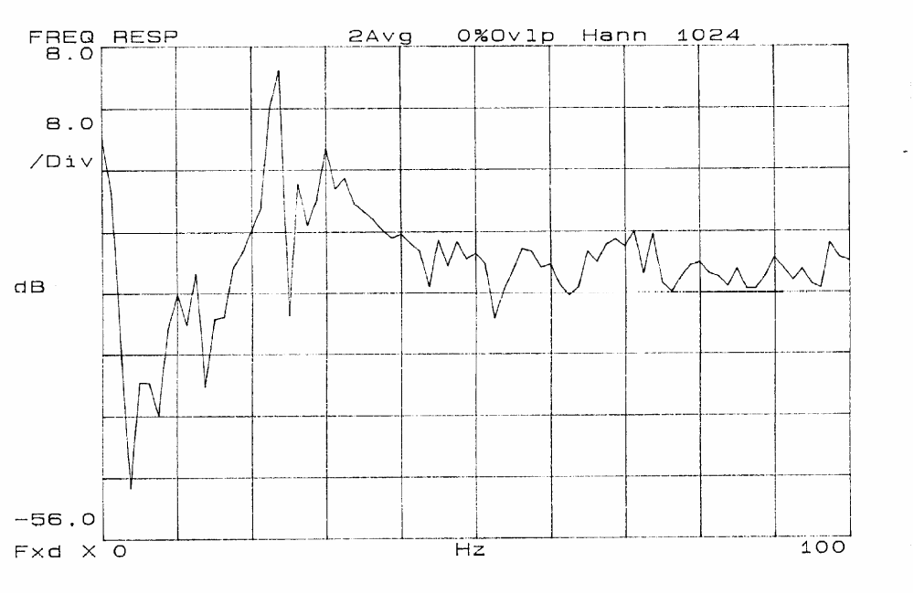
Figure 5. Open Loop Response, Top Plate Accelerometer 3, Exp 30, Run 1
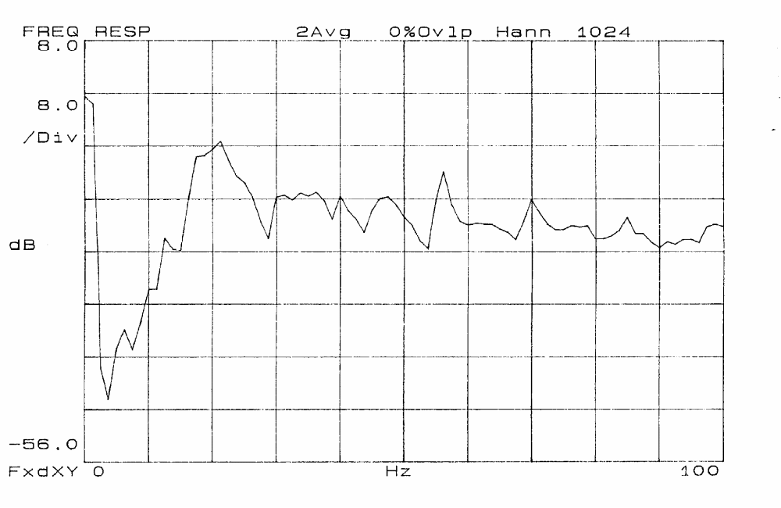
Figure 6. Closed Loop Response, Top Plate Accelerometer 3, Exp 30, Run 1

Staff Engineer, System Dynamics & Test Engineering Redondo Beach, CA 90278
Staff Engineer, Avionics Electronics Redondo Beach, CA 90278

